**CS5590 VC – Lab 2 Sirisha Pakalapati**

Created a mobile application using json, Jquery Mobile(JavaScript), Html, CSS for Lab 2 Assignment

I have developed a client application which is an account creation. Here I have used the geonames web service for the retrieval of the state and the city by giving zip code and country name.

Steps: User is at the main page, they have to give the user name, password, address, zip code and the country name. You can see in the below screen shot. 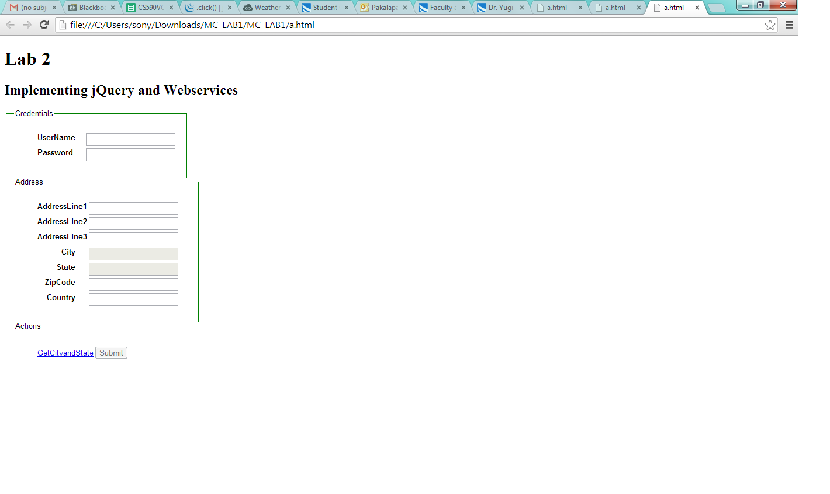 After giving your user name, password, address, zip code, country name you have to click on the get city and state. By using the web service geonames state and city are retrieved. 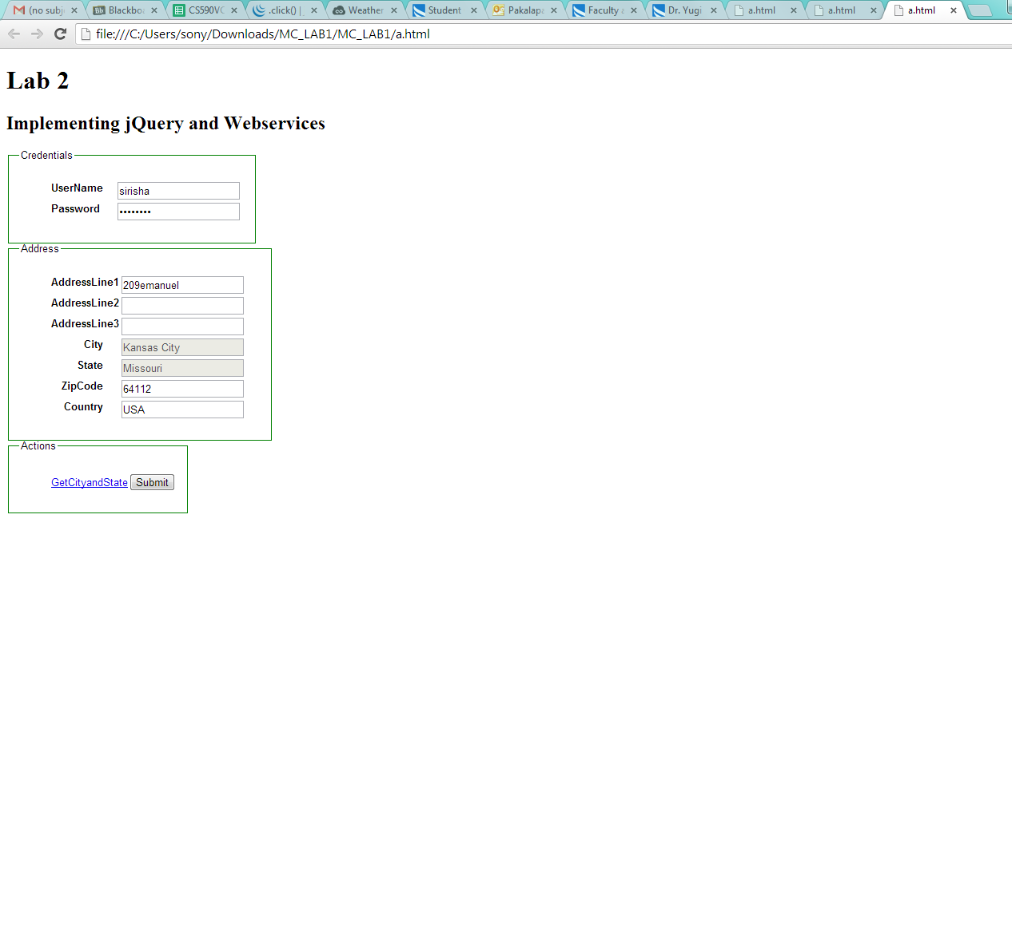Here I have disabled submit option before the retrieval of state and city because it may cause some controversies. After that when you submit you will get a prompt stating that you have successfully created your account .. uiu

YoyYYYYYYu

yippp